**Abstract**

Designing a PC software for Breast Cancer Detection was the main objective of this project. The main aim was to enable the user to diagnose the presence of breast cancer using a tool in which they can enter their details of medical report.

To develop a Breast Cancer Detection System there are several programming languages that are being used. Some of the programming languages we needed to sharpen our skills were Python, Data Science and many more. This report takes us through all the details of the system proposed to be designed, knowledge and experience gathered during this period

**Chapter 1**

**Introduction**

**1.1 Introduction**

Breast cancer (BC) is one of the most common cancers among women worldwide, representing the majority of new cancer cases and cancer-related deaths according to global statistics, making it a significant public health problem in today’s society.

The early diagnosis of BC can improve the prognosis and chance of survival significantly, as it can promote timely clinical treatment to patients. Further accurate classification of benign tumors can prevent patients undergoing unnecessary treatments. Thus, the correct diagnosis of BC and classification of patients into malignant or benign groups is the subject of much research. Because of its unique advantages in critical features detection from complex BC datasets, machine learning (ML) is widely recognized as the methodology of choice in BC pattern classification and forecast modelling.

Classification and data mining methods are an effective way to classify data. Especially in medical field, where those methods are widely used in diagnosis and analysis to make decisions.

Recommended Screening Guidelines:

Mammography. The most important screening test for breast cancer is the mammogram. A mammogram is an X-ray of the breast. It can detect breast cancer up to two years before the tumor can be felt by you or your doctor.

Women age 40–45 or older who are at average risk of breast cancer should have a mammogram once a year.

Women at high risk should have yearly mammograms along with an MRI starting at age

**1.2 PROBLEM DEFINITION**

**Identify the problem**

Breast cancer is the most common malignancy among women, accounting for nearly 1 in 3 cancers diagnosed among women in the United States, and it is the second leading cause of cancer death among women. Breast Cancer occurs as a results of abnormal growth of cells in the breast tissue, commonly referred to as a Tumor. A tumor does not mean cancer - tumors can be benign (not cancerous), pre-malignant (pre-cancerous), or malignant (cancerous). Tests such as MRI, mammogram, ultrasound and biopsy are commonly used to diagnose breast cancer performed.

**Expected outcome**

Given breast cancer results from breast fine needle aspiration (FNA) test (is a quick and simple procedure to perform, which removes some fluid or cells from a breast lesion or cyst (a lump, sore or swelling) with a fine needle similar to a blood sample needle). Since this build a model that can classify a breast cancer tumor using two training classification:

1. 1= Malignant (Cancerous) - Present
2. 0= Benign (Not Cancerous) -Absent

**1.3 Scope and Motivation**

**1.3.1 Scope**

The scope of this project is to aid the medical science by the evolution of a system capable of making predictions about breast cancer by using the patients report.

Further studies and research on this project may lead to better model and better accuracy score of the model.

**1.3.2 Motivation**

There are a lot of increase in numbers of patients who are diagnosed with breast cancer each year. This rapid increase of numbers is gaining attention of lot of people towards the severity of the problem.

**Chapter – 2**

**Literature Survey**

**Some Risk Factors for Breast Cancer**

The following are some of the known risk factors for breast cancer. However, most cases of breast cancer cannot be linked to a specific cause. Talk to your doctor about your specific risk.

**Age:** The chance of getting breast cancer increases as women age. Nearly 80 percent of breast cancers are found in women over the age of 50.

**Personal history of breast cancer:** A woman who has had breast cancer in one breast is at an increased risk of developing cancer in her other breast.

**Family history of breast cancer:** A woman has a higher risk of breast cancer if her mother, sister or daughter had breast cancer, especially at a young age (before 40). Having other relatives with breast cancer may also raise the risk.

**Genetic factors:** Women with certain genetic mutations, including changes to the BRCA1 and BRCA2 genes, are at higher risk of developing breast cancer during their lifetime. Other gene changes may raise breast cancer risk as well.

**Childbearing and menstrual history:** The older a woman is when she has her first child, the greater her risk of breast cancer. Also at higher risk are:

* Women who menstruate for the first time at an early age (before 12)
* Women who go through menopause late (after age 55)
* Women who’ve never had children

**Research Papers**

1. Breast Cancer Wisconsin (Diagnostic) Dataset –

Features are computed from a digitized image of a fine needle aspirate (FNA) of a breast mass. They describe characteristics of the cell nuclei present in the image.

**Repository:**<https://archive.ics.uci.edu/ml/datasets/Breast+Cancer+Wisconsin+%28Diagnostic%29>

1. W.N. Street, W.H. Wolberg and O.L. Mangasarian. Nuclear feature extraction for breast tumor diagnosis. IS&T/SPIE 1993 International Symposium on Electronic Imaging: Science and Technology, volume 1905, pages 861-870, San Jose, CA, 1993.
2. O.L. Mangasarian, W.N. Street and W.H. Wolberg. Breast cancer diagnosis and prognosis via linear programming. Operations Research, 43(4), pages 570-577, July-August 1995.
3. W.H. Wolberg, W.N. Street, and O.L. Mangasarian. Machine learning techniques to diagnose breast cancer from fine-needle aspirates. Cancer Letters 77 (1994) 163-171.
4. W.H. Wolberg, W.N. Street, and O.L. Mangasarian. Image analysis and machine learning applied to breast cancer diagnosis and prognosis. Analytical and Quantitative Cytology and Histology, Vol. 17 No. 2, pages 77-87, April 1995.
5. W.H. Wolberg, W.N. Street, D.M. Heisey, and O.L. Mangasarian. Computerized breast cancer diagnosis and prognosis from fine needle aspirates. Archives of Surgery 1995;130:511-516.
6. W.H. Wolberg, W.N. Street, D.M. Heisey, and O.L. Mangasarian. Computer-derived nuclear features distinguish malignant from benign breast cytology. Human Pathology, 26:792--796, 1995.
7. Machine Learning for Cancer Diagnosis and Prognosis - http://pages.cs.wisc.edu/~olvi/uwmp/cancer.html
8. SVM - https://link.springer.com/chapter/10.1007/978-3-642-34041-3_27
9. The construction of SVM https://downloads.hindawi.com/journals/cin/2015/212719.pdf
10. Support Vector Machines- http://web.cs.iastate.edu/~honavar/hearst-svm.pdf
11. A Study on Support Vector Machine based Linear and Non-Linear Pattern Classification - https://ieeexplore.ieee.org/abstract/document/8908018

**Chapter – 3**

**Working Methodology**

**3.1 Design Concept**

**The Data**

The dataset used in this story is publicly available and was created by Dr. William H. Wolberg, physician at the University Of Wisconsin Hospital at Madison, Wisconsin, USA. To create the dataset Dr. Wolberg used fluid samples, taken from patients with solid breast masses and an easy-to-use graphical computer program called Xcyt, which is capable of perform the analysis of cytological features based on a digital scan. The program uses a curve-fitting algorithm, to compute ten features from each one of the cells in the sample, than it calculates the mean value, extreme value and standard error of each feature for the image, returning a 30 real-valuated vector.

Attribute Information:

1. ID number 2) Diagnosis (M = malignant, B = benign) 3–32)  
     
   Ten real-valued features are computed for each cell nucleus:
2. radius (mean of distances from center to points on the perimeter)
3. texture (standard deviation of gray-scale values)
4. perimeter
5. area
6. smoothness (local variation in radius lengths)
7. compactness (perimeter² / area — 1.0)
8. concavity (severity of concave portions of the contour)
9. concave points (number of concave portions of the contour)
10. symmetry
11. fractal dimension (“coastline approximation” — 1)

**3.2 Design Objective**

**Predictive model using Support Vector Machine (SVM)**

**Supervised learning**

Supervised learning is the machine learning task of learning a function that maps an input to an output based on example input-output pairs. It infers a function from labeled training data consisting of a set of training examples. In supervised learning, each example is a pair consisting of an input object (typically a vector) and a desired output value (also called the supervisory signal). A supervised learning algorithm analyzes the training data and produces an inferred function, which can be used for mapping new examples. An optimal scenario will allow for the algorithm to correctly determine the class labels for unseen instances. This requires the learning algorithm to generalize from the training data to unseen situations in a "reasonable" way

**Predictive model using Support Vector Machine (SVM)**

Support vector machines (SVMs) learning algorithm will be used to build the predictive model. SVMs are one of the most popular classification algorithms, and have an elegant way of transforming nonlinear data so that one can use a linear algorithm to fit a linear model to the data (Cortes and Vapnik 1995)

Kernelized support vector machines are powerful models and perform well on a variety of datasets.

1. SVMs allow for complex decision boundaries, even if the data has only a few features.
2. They work well on low-dimensional and high-dimensional data (i.e., few and many features), but don’t scale very well with the number of samples.
3. SVMs requires careful preprocessing of the data and tuning of the parameters. This is why, these days, most people instead use tree-based models such as random forests or gradient boosting (which require little or no preprocessing) in many applications.
4. SVM models are hard to inspect; it can be difficult to understand why a particular prediction was made, and it might be tricky to explain the model to a nonexpert.

Running an SVM on data with up to 10,000 samples might work well, but working with datasets of size 100,000 or more can become challenging in terms of runtime and memory usage.

**3.3 System Design**

**Flowchart**

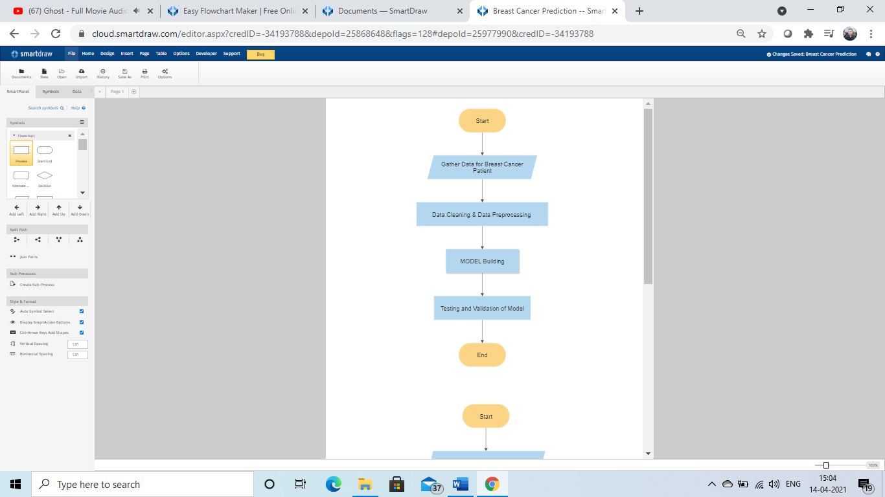

**DFD**

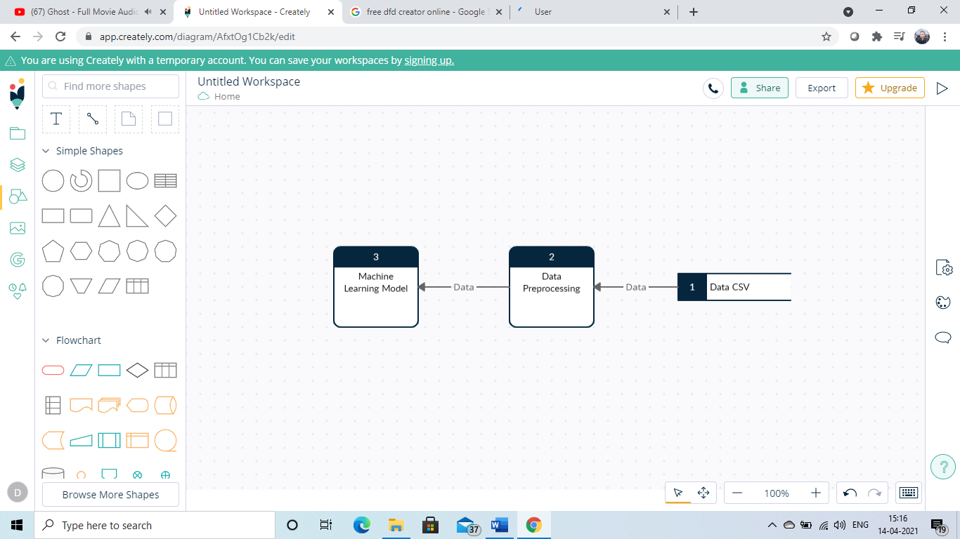

**Block Diagram**

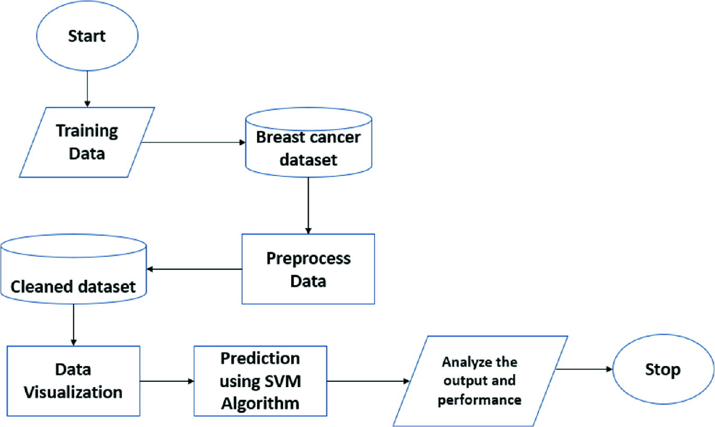

**3.4 Software Model of Project**

The software development model used in this project is Waterfall Model.

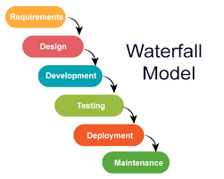

**Chapter 4**

**Implementation Challenges**

The first and foremost challenge in any ML Project is getting the right dataset that fit our need.

The second challenge is to pre-process our data so that there are no missing values.

The third challenge is to gain accurate prediction and tune our model.

**Chapter 5**

**Application and Limitation**

**Application**

The application of this project can be seen in medical industry where Machine can predict the presence of cancer od breast.

**Limitation**

1. Accuracy is attained over time.
2. Less available dataset

**Chapter 6**

**The Conclusion**

Breast cancer is cancer that forms in the cells of the breasts.

After skin cancer, breast cancer is the most common cancer diagnosed in women in the United States. Breast cancer can occur in both men and women, but it's far more common in women.

Substantial support for breast cancer awareness and research funding has helped created advances in the diagnosis and treatment of breast cancer. Breast cancer survival rates have increased, and the number of deaths associated with this disease is steadily declining, largely due to factors such as earlier detection, a new personalized approach to treatment and a better understanding of the disease.

It is difficult to manually determine the odds of getting breast cancer based on risk factors. However, machine learning techniques are useful to predict the output from existing data.

We have successfully used our dataset to predict whether a person may have Breast Cancer.

**References**

[1] <https://www.programiz.com/python-programming>

[2] [www.w3schools.com](http://www.w3schools.com/)

[3] wikipedia

[4] <https://pandas.pydata.org/pandas-docs/stable/user_guide/io.html>

[5] <https://wiki.python.org/moin/TkInter>

[6] <https://www.mayoclinic.org/diseases-conditions/breast-cancer/symptoms-causes/syc-20352470>